REPORT ON ‘TECHNOTRONICS ” I.T. Event

Department of Computer Application , DMs College and Research, Assagao – Bardez Goa, Organized two day State level IT event ''Technotronics ’ on 3rd and 4th March 2020. Various technical and non-technical events were organized. Students of Computer Science department participated in various events and won various prizes

Android-Development – won 1st Place by ( Pratiksha Rane, Agnesh Naik)
DJ – won 1st Place by ( Yash Kurdikar)
Recycle IT - won by (Michael Fernandes, Pritesh Gawade)

The Computer Science dept. congratulates all the winners and the participants of the event. Well done. Keep up the Spirit !!!!

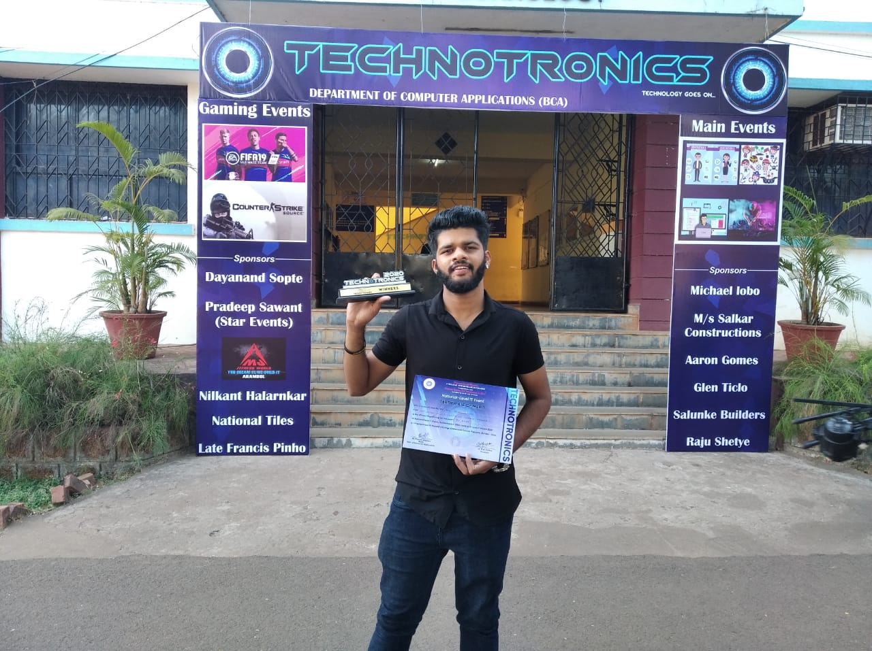
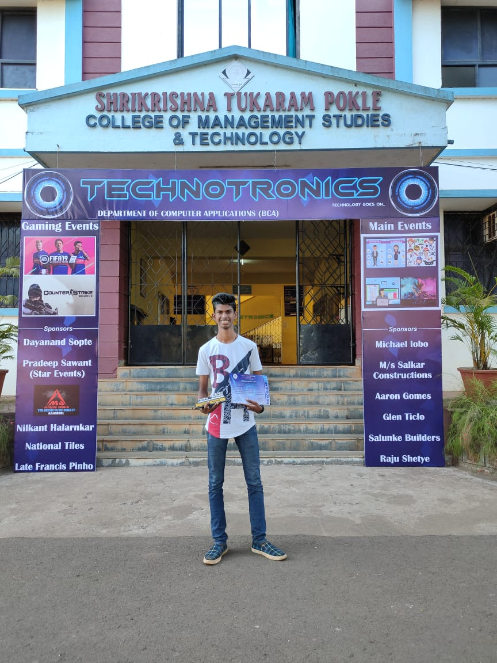
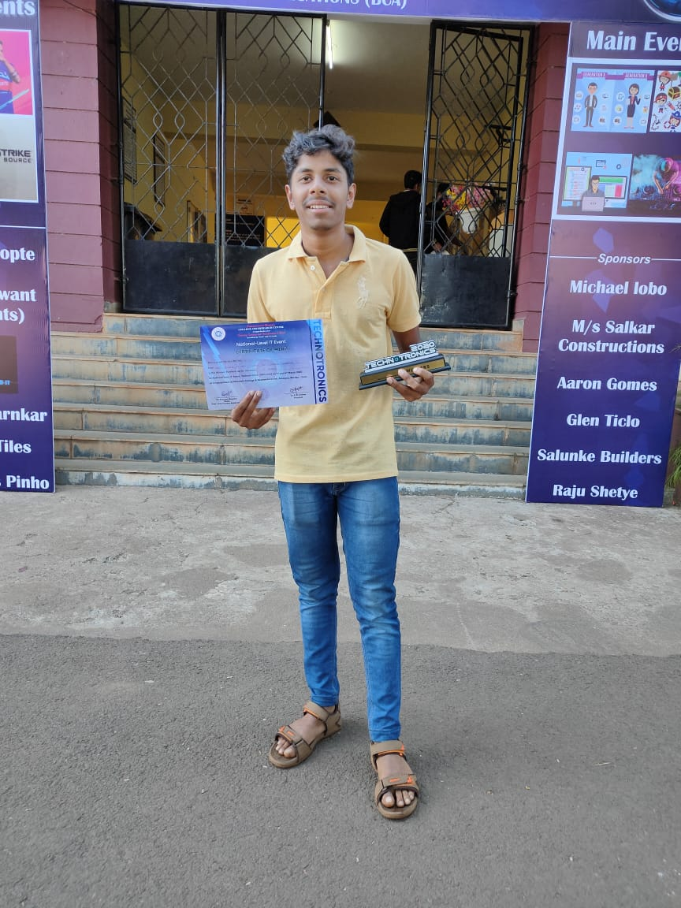
Yash Kurdikar Michael Fernandes Pritesh Gawade

