National Level Camps participation
- Cadet Keerti Thakur participated at National level Online Ek Bharat Shreshth Bharat Saptah Phase – III: 21 To 26 Sep 20. under the aegis of NCC Gp Kakinada by 18 Andhra Bn NCC on behalf of NCC Dte Andhra Pradesh & Telangana.
- Cadet Dipankar Shailesh Jadhav attended Pre Republic-Day Camp I, 2020 of five days at Belgaum.
- Cadet Astha Amar Sangle honoured with certificate for representing Goa at Pre RDC 2, NCC Directorate, Bangalore as a part of the Karnataka & Goa Republic Day Contingent 2021. She has also been part of pair selected for Guard of Honour to Governor of Goa state, Hon. Bhagat Singh Koshyari at Home Function, 2021 of RDC Cadets, Participants.
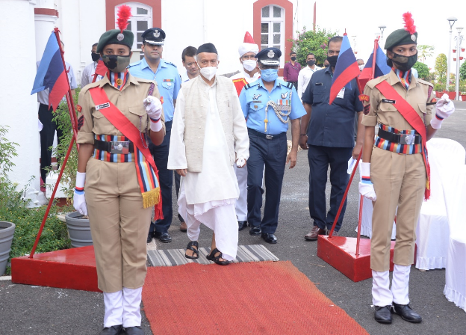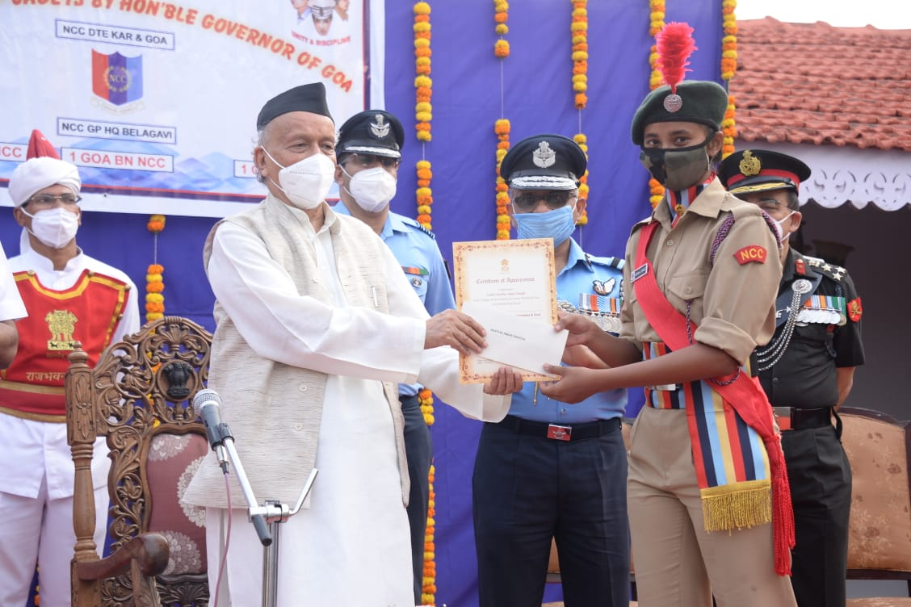
- Cadet Deepraj Desai, Cadet Abhay Giri, Cadet Afsana Ani, Cadet Arpita Dilip Patil, Cadet Yachna Yesso Sawant Talaulikar, Cadet Vishal Sanjay Jaswal, Cadet Dipankar Shailesh Jadhav has participated in HELP (Heartfulness – Experience Life’s Potential) Program. The program was organised online by Heartfulness Education Trust, Hyderabad in North East Region (NER) Directorate.
- Cadet Dipankar Shailesh Jadhav and Cadet Aastha Amar Sangle represented state at Phase VI-Online Ek Bharat Shreshth Bharat (EBSB) Saptah Webinar 15th Mar 2021 to 20th Mar 2021, organized by NCC Directorate Bihar and Jharkhand.

College NCC Activities
- On the occasion of Kargil Vijay Diwas 2020, organised by 1 Goa Bn, Panaji Goa. 05 Cadets represented their skills through their creativity like, Cadet Vishal Kumar Sanjay Jaswal, Harish Bimal Singha, and Aastha Amar Sangle in Poster making competition. Cadet Faaiza Mehboob Subani Attar and Keerti Thakur, in essay writing competition.
- Observed ‘Tree Plantation Pakhwada’ from 10th July 2020 to 25th July 2020. The objective of Tree Plantation was towards forming a personal connection between the cadets and trees. The activity was conducted by using the mobile based application to register themselves and submit plantation details along with a picture for geo-tagging.
- NCC Unit in collaboration with Department of Geography, Green initiative Cell has made a point to work for community where, a Tree Plantation Drive was held on the event of Independence Day as a part of Community Service on 15th August 2020 at Village Panchayat Surla. The guest for the program known environmentalist Mr. Rajendra P. Kerkar.
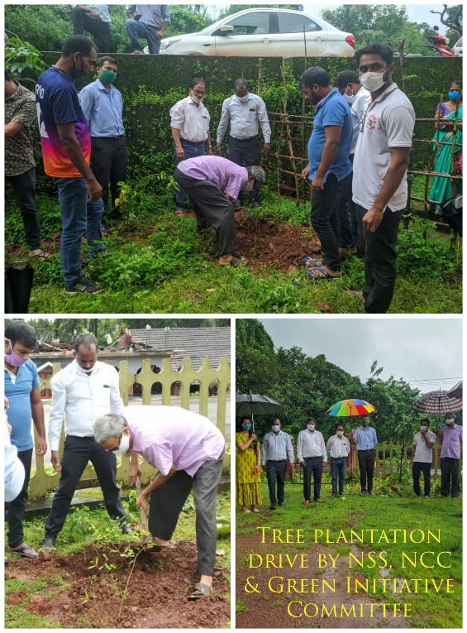

- Participation of ANO and NCC cadets in the Gandhi Jayanti Celebration in College involving cadets, who participated through Google meet 02.10.2020 morning at 10.00 am. NCC Cadets of the Second year has organized महात्मा गांधी - विचार मंथन at 5.00 to 6.00 pm.
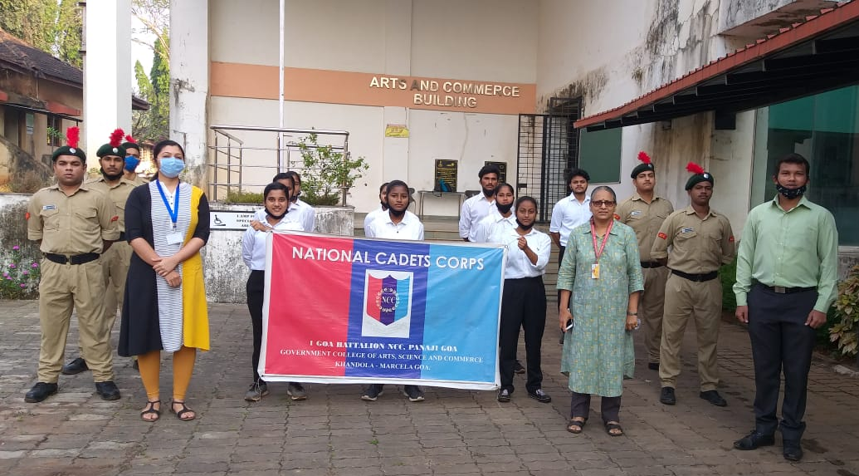
- 11th National Voters’ Day (NVD) to be celebrated on Monday 25th January 2021, from 10.30 am in our college NCC Cadets has taken the ‘National Voters Day Pledge’. The theme for this year’s NVD, ‘Making Our Voters Empowered, Vigilant, Safe and Informed’, envisages active and participative voters.

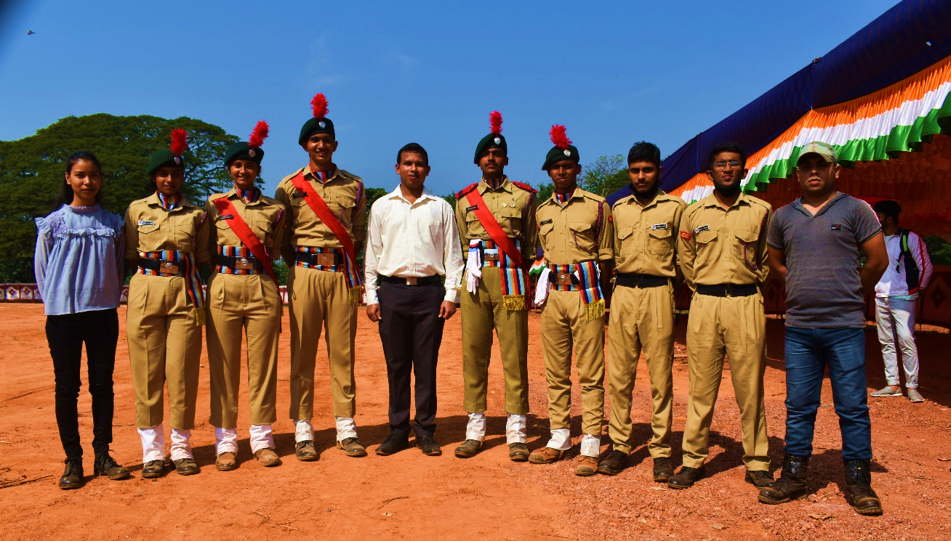
- Four NCC cadets (SD/SW) Cadet Vishal Sanjay Jaswal, Cadet Dipankar Shailesh Jadhav, Cadet Faaiza Mehboob Subani Attar and Cadet Aastha Amar Sangle has participated for March Pasts squad of 1 Goa Battalion, Panaji for the celebration of Goa Liberation Day 2020 at Campal Panaji, Goa.

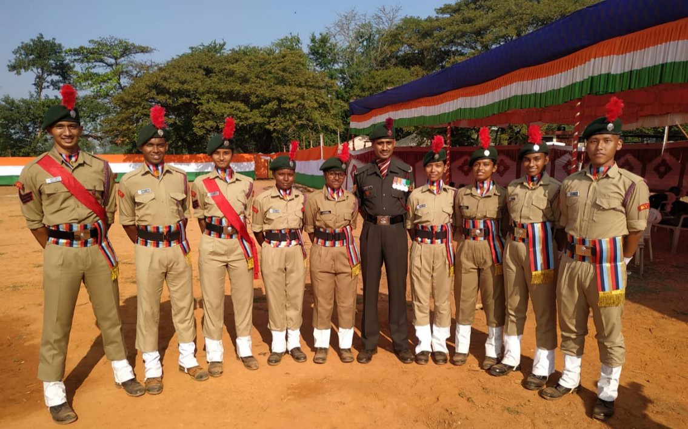
- Nine Cadets NCC cadets (SD/SW), Cadet Vishal Sanjay Jaswal, Cadet Dipankar Shailesh Jadhav, Cadet Faaiza Mehboob Subani Attar, Cadet Aastha Amar Sangle, Cadet Snedil Balkrishna Busa, Cadet Snehal Balkrishna Busa, Cadet Harish Bimal Singha, Cadet Manisha Ramesh Prasad and Cadet Keerti Thakur has participated for March Pasts squad of 1 Goa Battalion, Panaji for the celebration of Goa Republic Day 2020 at Campal Panaji, Goa.

- Annual Training Camp (ATC):
As a part of Annual Training of NCC second year cadets along with teacher in charge Ms. Ankita Naik participated at NCC Cader Camp 2021 at Goa Engineering College, Farmagudi, Ponda, Goa from 8th Feb to 10th Feb 2021.
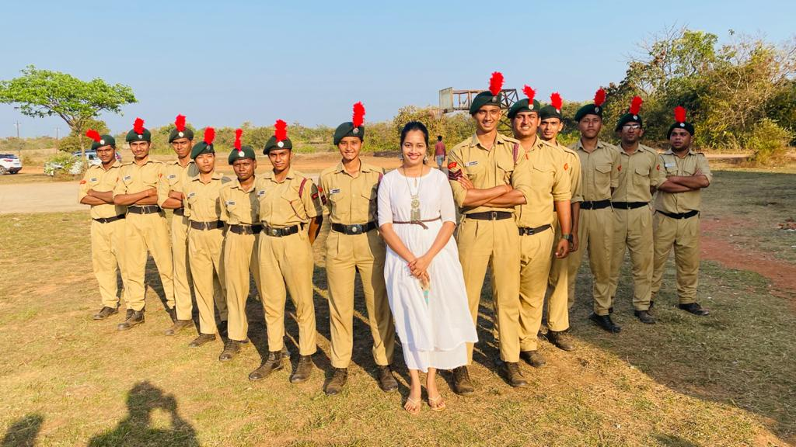

- Celebration of Azadi ka Amrut Mahotsav Rally at Azad Maidan:
To commemorate 75 years of India’s independence, the anniversary of ‘Dandi March’ our college second year cadets participated in Azadi ka Amrut Mahotsav Rally at Azad Maidan on 12th March 2021.
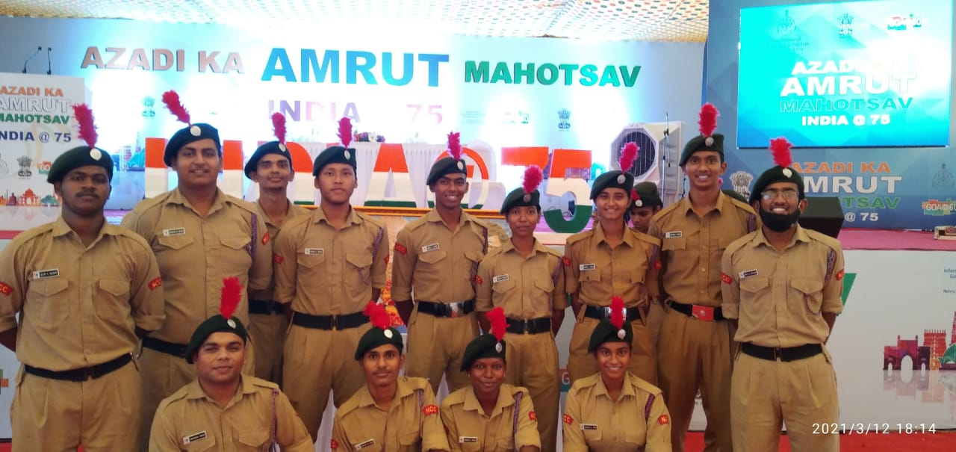
- 7th International Yoga Day 2021, celebrations were held through online mode on the theme of ‘YOGA FOR WELLNESS’. The task was undertaken by cadets to practice yoga at home and to click the video of a half minute. All collected videos are compiled in one documentary format. A documentary set was plan with idea of 21 short videos of 21 Asana, practised for a 21-day means committing to practicing yoga every day for 21 days straight.
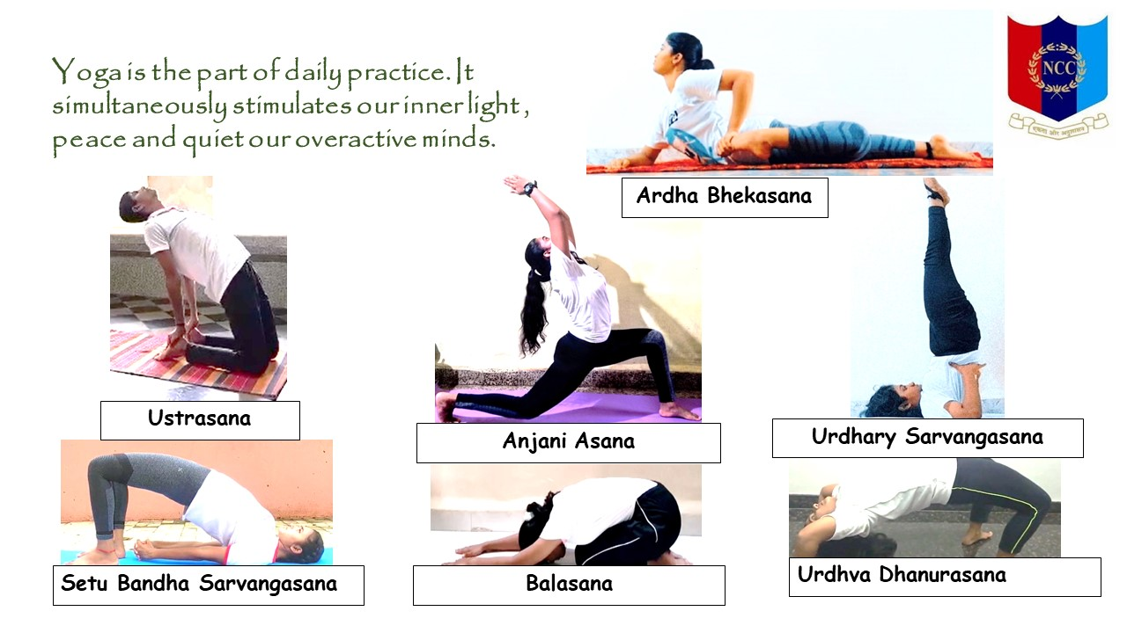

- Seed balls preparation by NCC Cadets - It is a crucial time to carrying out sustainable change, nature-loving cadets have taken to greening their surroundings with a firm idea—seed bombing. Cadets have taken initiative to prepare 1000 seed balls, with a variety of local species of fruit-bearing trees and vegetable seeds in the beginning monsoon season 1st June to 15th June 2021.
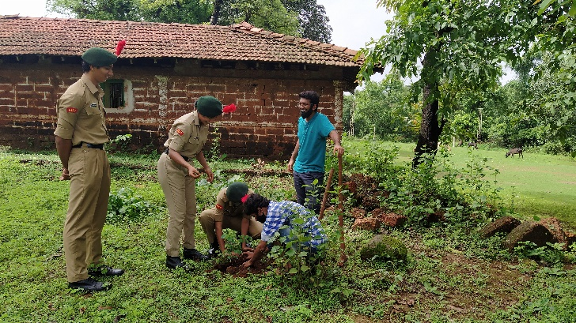
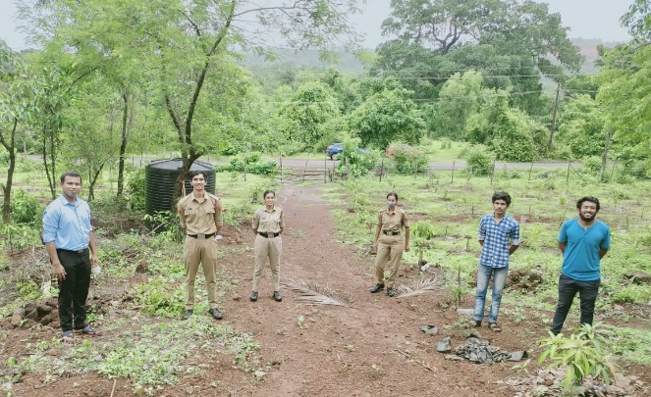
- Seed balls and plantation of medicinal plants drive at Surla Panchayat Cadets arranged seed balls and college donated medicinal plants were placed by organizing a drive at Surla Panchayat on 20th June 2021 (Sunday). In order to improve green cover in local area NCC Unit of GCASCK is planning to have more such collaborative effort with neighbouring panchayats.

